SIGNAGE REQUEST FORM FOR TN SPONSORED EVENTS

Please complete this form at least ten (10) business days prior to collection. Other smaller Tourism Noosa signage/banner options may be suitable so please make contact to discuss these.
Email form to:
Tony Kimmins - tony.kimmins@ironman.com - 0402 128 162 & Jemma Baker jemma.baker@ironman.com
And please copy in Lee Huber - lee@tourismnoosa.com.au

Event name:
Contact name:
Phone number:
Date & Time of Requested Pick Up: (Monday to Friday 8am – 4pm)
Who is collecting signage?
Date of signage return:

Signage Item  (Please see signage stock library document for more details) | Qty | Sign Out ++ | Sign In * | Return Condition *
Crowd Control Barrier Mesh - 1CCB 2.5 m wide
Crowd Control Barrier Mesh - 3CCB 7.6m wide
High Panel Fence Mesh - 3P
CF Sign Tourism Noosa 1800mm x 900mm
CF Sign Noosa 1800mm x 900mm
CF Sign Tourism Noosa 2400mm x 1100mm
CF Sign Noosa 2400mm x 1100mm
Feather Banner / Bowflag
Ground spike
Base plate
Small Corflute Toblerone
Large Foam Toblerone
Tourism Noosa Carpet
Welcome to Noosa Banner
++ Person collecting signage to initial *IRONMAN staff to complete
Signage must be returned in the same condition as supplied. Please ensure that any signage is packaged properly, is clean and dry and we are made aware of any damages or missing items. Any damage or replacements required will be charged at replacement rates.
Signage collection & return address:
Attn: Jemma Baker or Brian Clancy,
IRONMAN: Phone: 1300 761 384

24 Lionel Donovan Drive, Noosaville

Examples: TOURISM NOOSA SIGNAGE OPTIONS

CORFLUTE SIGNS
1800 X 900 CORFLUTE PANEL SINGLE SIDED WITH EYELETS IN EACH CORNER

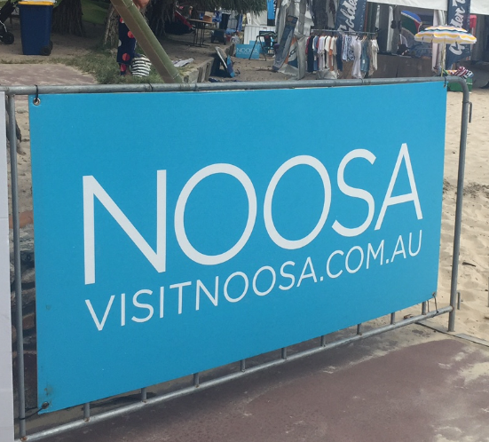

MESH SIGNAGE
2450 X 890MM POLYMESH BANNERS WITH EYELETS

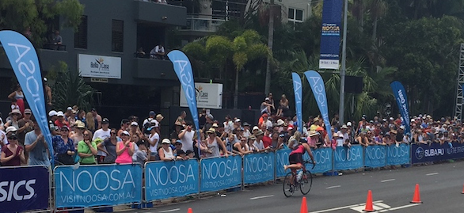

BANNER FLAGS
3.4M FEATHER BANNERS

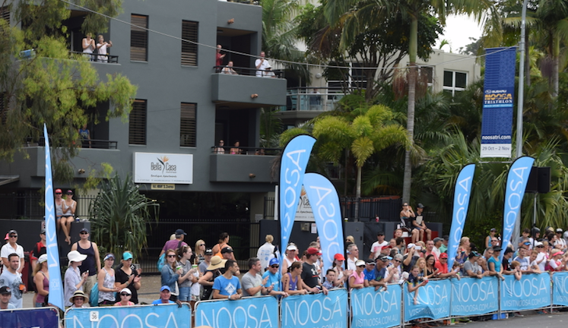

SMALL TOBLERONES
2400 x 920mm Toblerone corflute A Frame
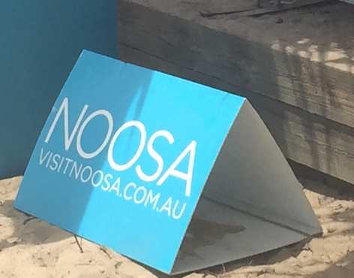

LARGE TOBLERONES PLEASE NOTE YOU WILL NEED A UTE TO TRANSPORT
2400 X 600MM Soft foam freestanding A Frames

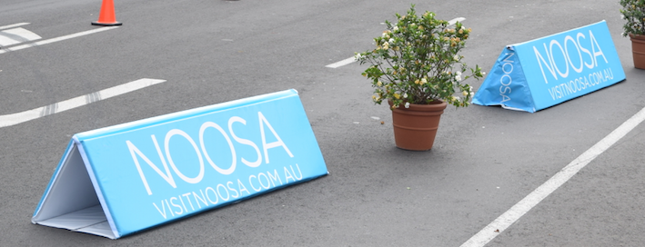

Signage Stock

