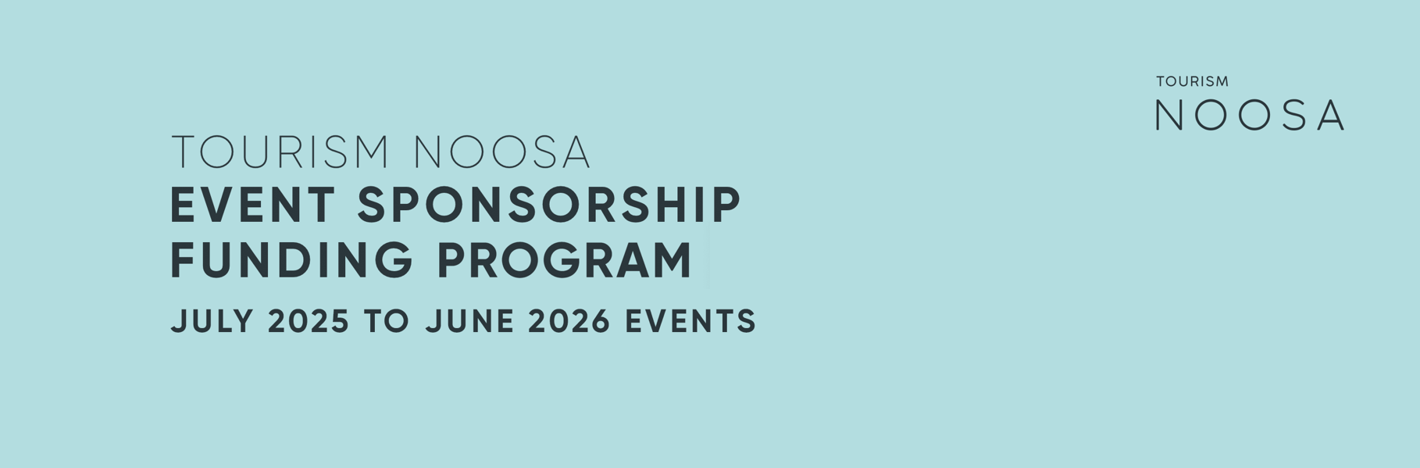
Tourism Noosa (TN) Event Funding applications for events held between 01 July 2025 and 30 June 2026 are now open with a closing date of Friday, 11 October 2024.

Aims and objectives of the event support program
Tourism Noosa takes an integrated destination management approach to marketing the Noosa region domestically and when appropriate internationally, and our activities are guided by the current Destination Noosa Strategy 2023-2027.

Tourism Noosa acknowledges that events can positively impact the regional economy and strengthen both the business and local community. Tourism Noosa is committed to building an iconic events calendar through targeted investment and adding, where possible, new events to encourage off-peak visitation and enable geographic dispersal.

Within that context, the aims and objectives of the Tourism Noosa Event Sponsorship Program are as follows:
- Generate local economic, environmental and social value in the Noosa region.
- Attract visitors - drive interstate and international visitation to the destination.
- Enhance the profile, appeal and visitation to the Noosa region's village communities.

Before completing your application, please read the Event Guidelines & Funding Assessment Criteria carefully. Tourism Noosa will provide a Post Event Report template and an opportunity to discuss reporting including the event’s sustainability objectives on approval of the Event Funding Application.

Please read all available information so you are familiar with these requirements prior to submitting your application. Tourism Noosa will provide a response on the application on or before 9 December 2024 (date subject to change).

If you have any queries regarding the application process, please contact events@tourismnoosa.com.au

Event guidelines and funding assessment criteria

Eligibility
Any event sponsored by Tourism Noosa must:
- Take place wholly within the Noosa region.
- Satisfy the regulatory requirements of existing COVID-19 safe event regulations, where applicable and relevant to the individual event, as determined by local, state and federal levels of government.
- All applicants should be a member of or be willing to become a member of Tourism Noosa.

Funding
The value of support offered by Tourism Noosa will be determined according to the event’s ability to satisfy the specific Event Funding Assessment Criteria outlined below. Event Sponsorship may comprise either/and/or cash and a marketing contribution.

Event Funding Assessment Criteria

Visitation | Event targets high-value travellers (participants and/or spectators), preferably from interstate and/or overseas.
 | Events staged over two or more days that encourage overnight stays, outside of school holidays and peak periods will be deemed more favourable.
 | Elements of the event have the potential to encourage geographic dispersal of visitors.
Sustainability | Event planning will include collaboration with the TN sustainability team to set and achieve agreed sustainability goals. These will be based on TN's Sustainable Event Criteria, which aims to lift event sustainability standards. For additional information, refer to Tourism Noosa’s Sustainable Event’s Guide “50 Shades of Green” in the Resources section below.
 | We are committed to ensuring Noosa is the most desirable and sustainable tourism destination for our visitors and local community. Events sponsored by TN will contribute to TN’s regenerative tourism program, Trees for Tourism, based on $1 per event participant.
Accessibility | TN is committed to being an inclusive destination. Please demonstrate the steps you are taking to make your event more inclusive and accessible and provide your Accessible Events Plan.
Marketing and brand alignment | Event is attractive to Noosa's target markets.
 | Event is aligned with Noosa's brand values.
 | There is suitable marketing lead time before the event (minimum 90 days.
 | A detailed marketing plan needs to be submitted to TN for approval.
 | Event organiser can provide TN with suitable event imagery and videos that showcase Noosa and the event.
Capacity to deliver | Event organiser has a proven record of staging successful events of similar size and nature.
 | Event organiser can provide on request relevant data on previously staged events as proof of capacity to deliver on criteria.
 | Event organiser will consider using local suppliers where possible.
Sound fiscal management | Event organisers have provided an accurate, detailed, forecasted event budget for the proposed event.
 | Sponsorship application provides a clear implementation plan.
Reporting | Event has systems in place to record data such as visitor numbers, visitor expenditure, and sustainability measures required for post-event reporting as part of the sponsorship agreement.
 | Event organisers agree to share with TN, in confidence, any additional relevant data collected on visitation and visitor expenditure that may aid TN in future event development and strategic planning.
Covid safety | Event organisers can successfully satisfy the relevant national, state and local government regulations associated with staging a COVID-safe event at the proposed time and obtain the appropriate permits, approvals and insurances.

Approval process
Applicants will receive an acknowledgment of receipt of application response via email.

Event applications will be notified on or before Friday 6 December 2024 (subject to change).

Particulars of the value of support offered will be issued to the applicant in writing in a
Letter of Offer from Tourism Noosa. Unsuccessful applicants will be invited to a debrief.

Resources
50 Shades of Green, a creative guide for sustainable event management link
Planning Accessible Events link
Queensland Accessible Event Guide link
Tourism Noosa Sustainable Event Criteria link

END

